# CS4112/CS54111 INTRODUCTION TO DATA SCIENCE

# Final Project- Bowei Yao - 0676099

The data that could indicate where America’s worst drivers are: The number of car crashes in each state (especially those where the driver was negligent in some way), how much insurance companies pay out, and how much insurance companies charge drivers. All three measures vary a lot across the country and no state is consistently at the bottom, but drivers in Texas don’t do very well on any of them. By contrast, drivers in Iowa, Indiana and Vermont are pretty good across the board.

# Exercise.1: Get dataset from Github:

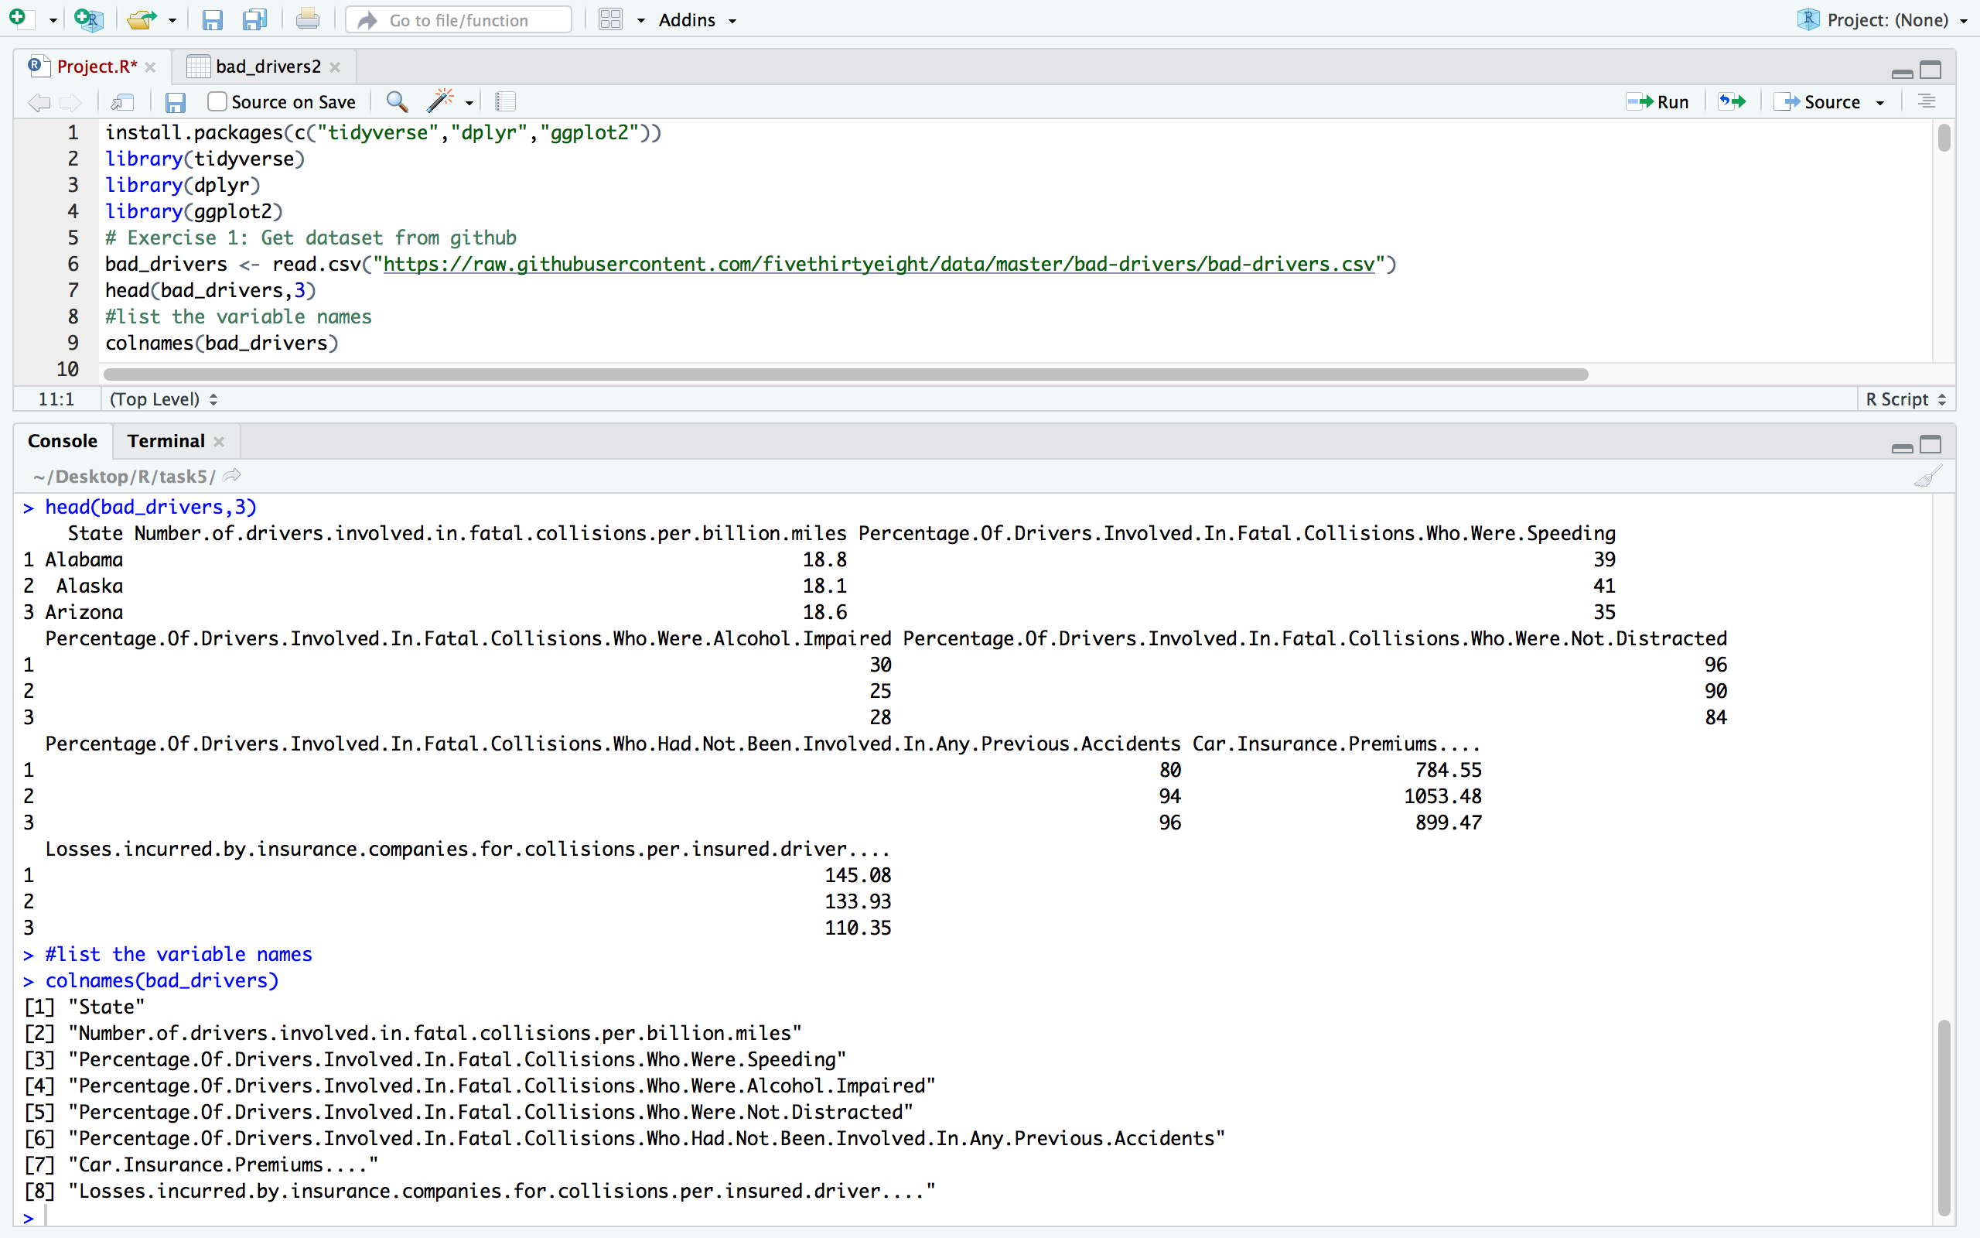

As we could see from the results, the variables names are too long to read and analyze, so I renamed those variables and pleased look at next exercise.

And noticed that, there are four factors having a percentage value, it should be transformed into a number value.

**Exercise 2: Since the variable names are too complicated, we change them into brief ones: nums(the total numbers of collisions), speeding, alcohol, not_distracted, first_collision and insurance_comp_loses :**

# 

Here are the simplified variable names data-frame and I print the first 9 rows out.

**Exercise3: Transfer the percentage value into the real numbers of people and create a new data-frame called 'bad_drivers2'**

# 

The result:

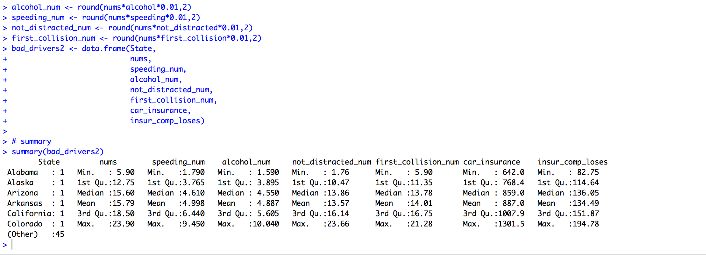

# 

**Exercise 4: list the first 9 rows of percentage transformed dataset:**

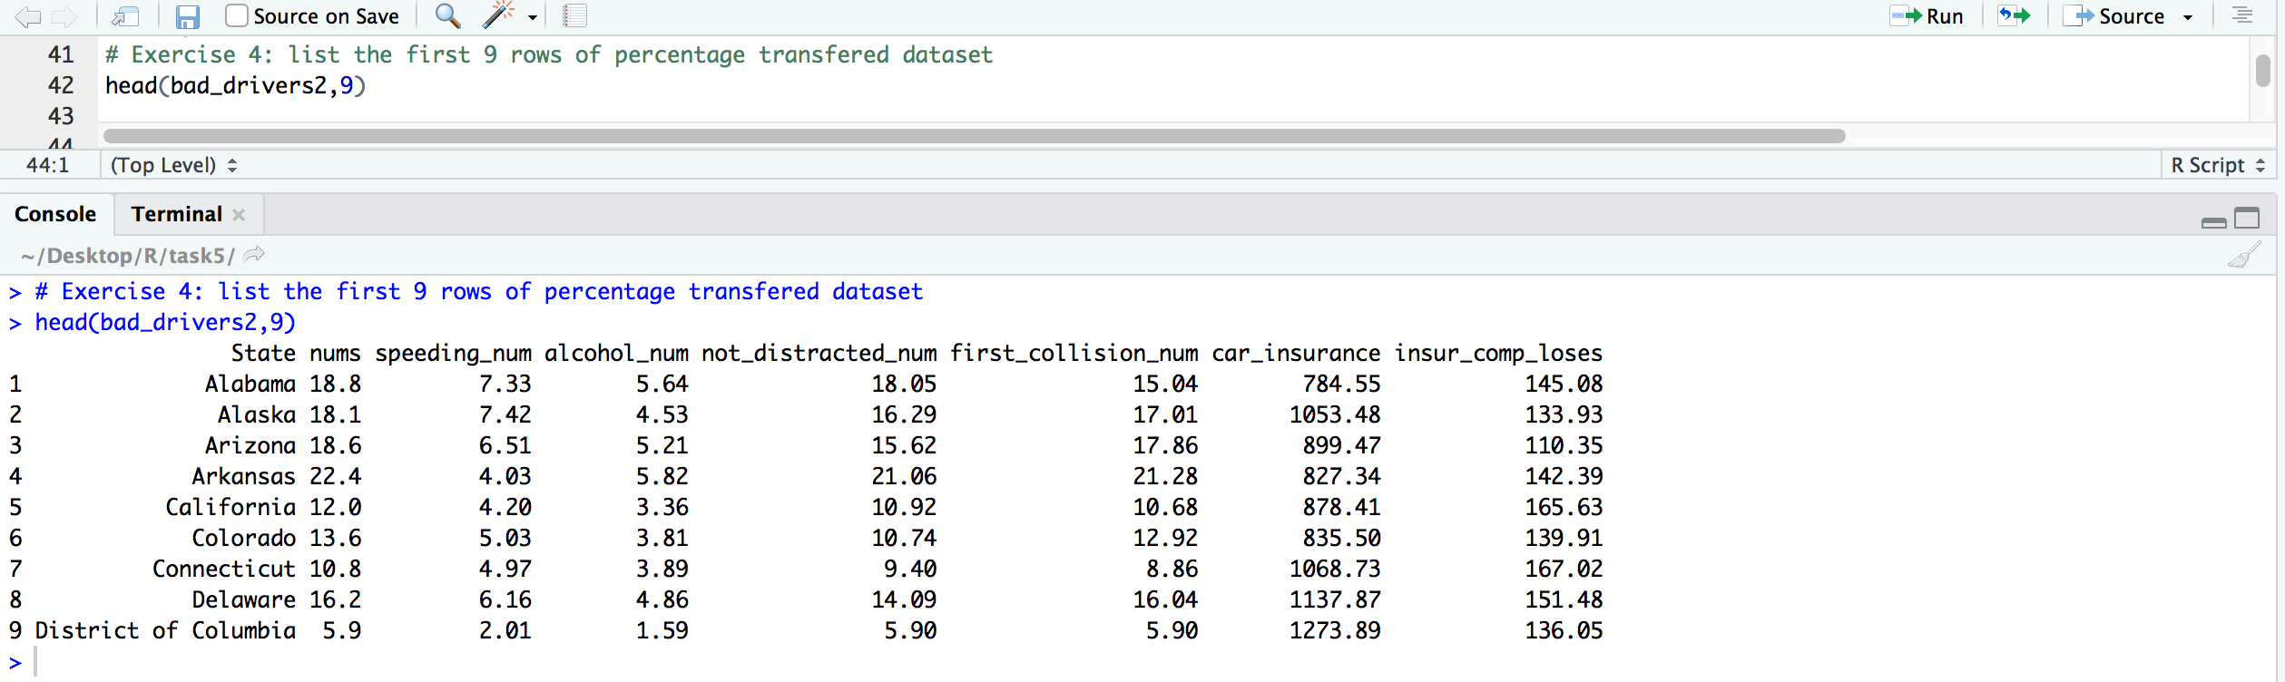

Now all the values in each type of collision that we have are the real numbers of collision value, instead of percentage value.

**Exercise 5: list the number of variables and observations:**

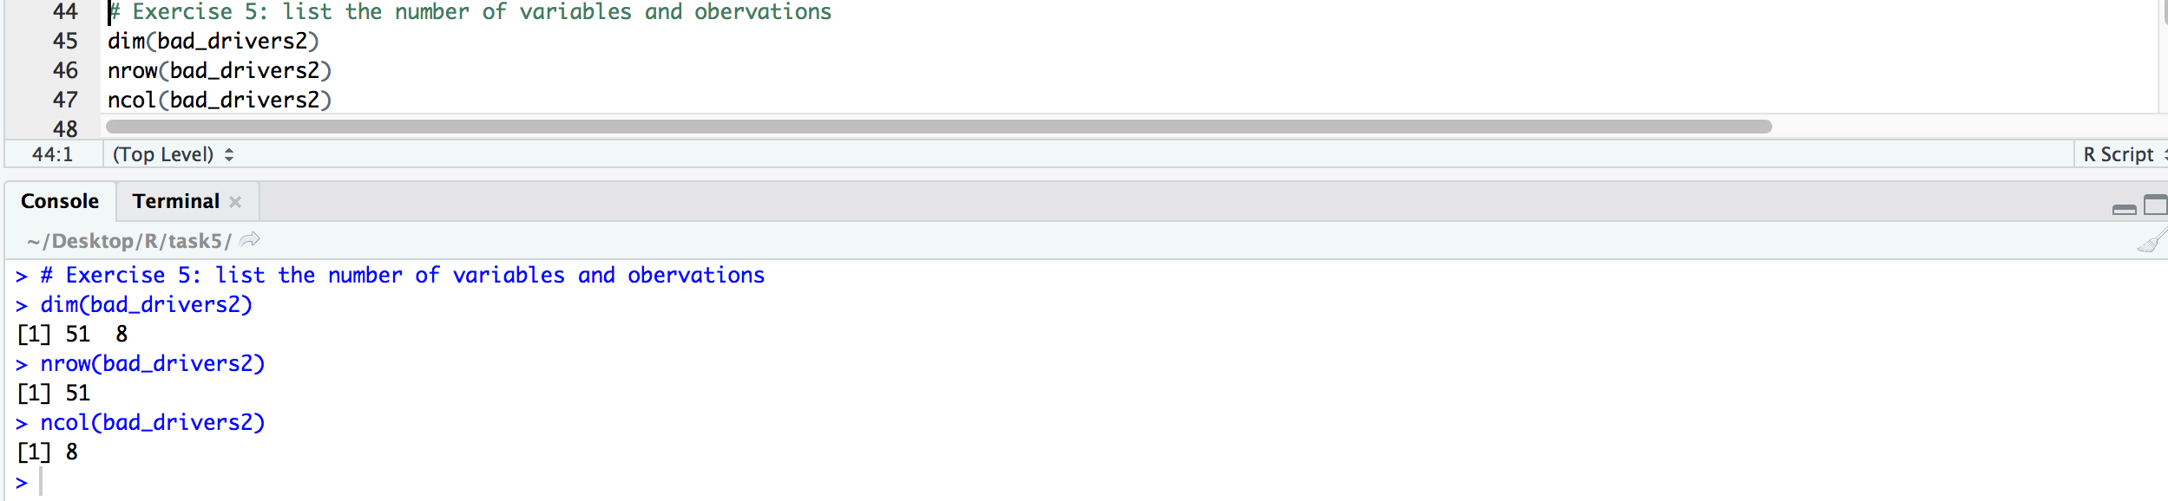

**Exercise 6: Use attach() function to avoid of using '$' and use it to calculate the mean value of car insurance in USA**

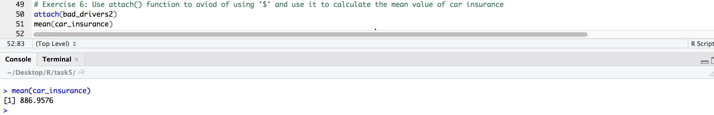

**Exercise 7: Sort data with descending collisions per billion miles(nums) in each State**

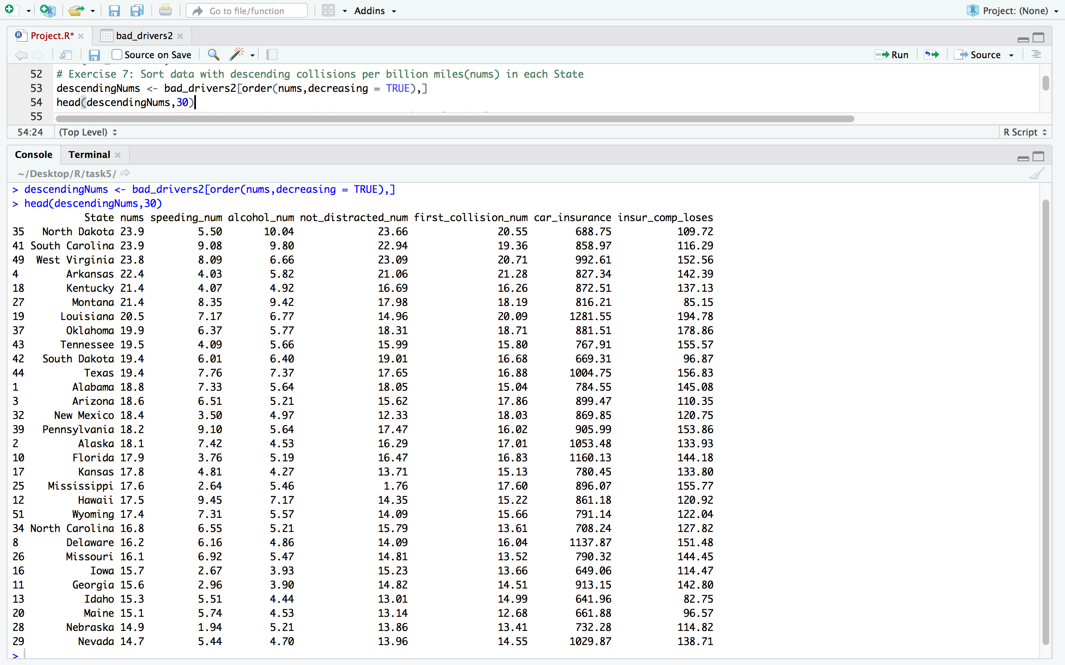

**Exercise 8: List all the States who exceed the average value of each factor**

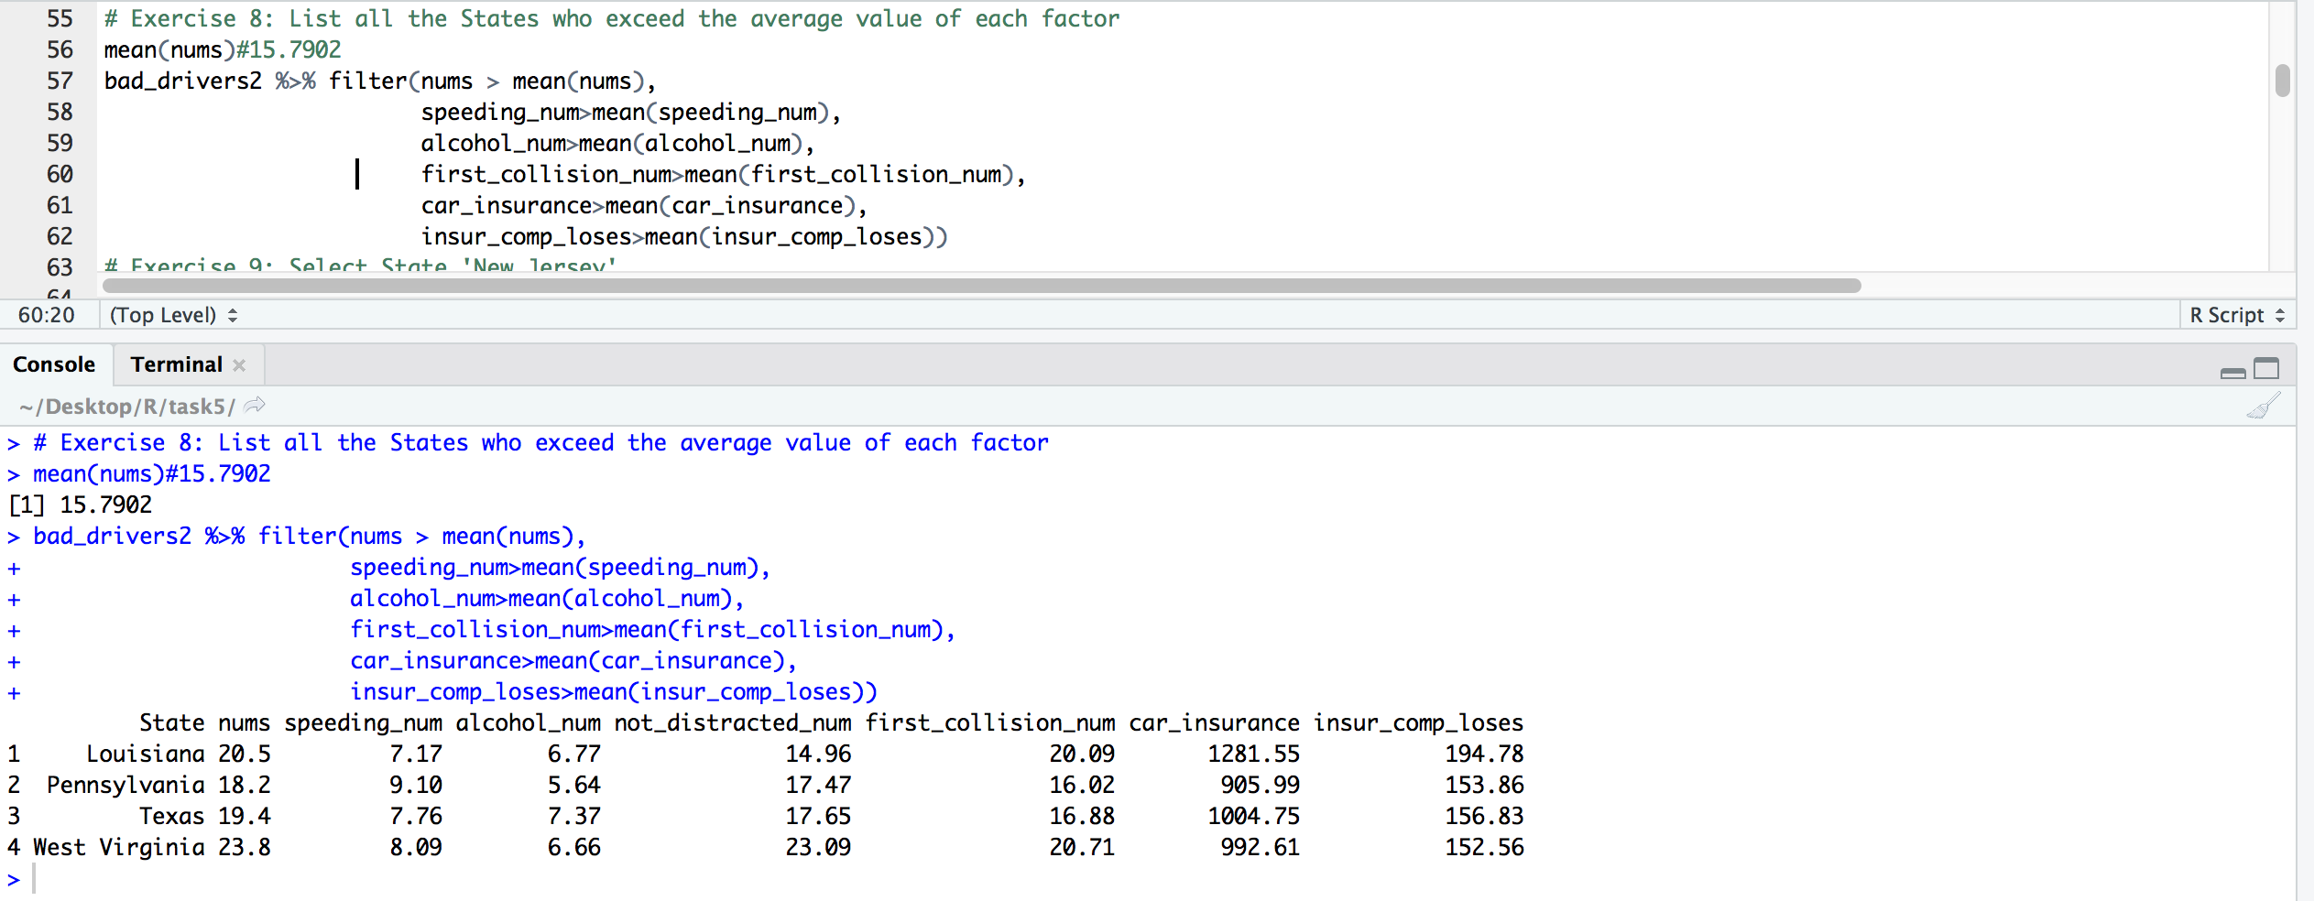

As we could see, the Louisiana, Pennsylvania, Texas and West Virginia are the top 4 States in USA that have the most severe collision record, and likely to say, they have the worst drivers in USA.

**Exercise 9: Select State 'New Jersey'**

# 

# Exercise 10: Plot the histogram of the number of Drivers Involved In Fatal Collisions Per Billion Miles In Each State with a descending trend and show the mean value line

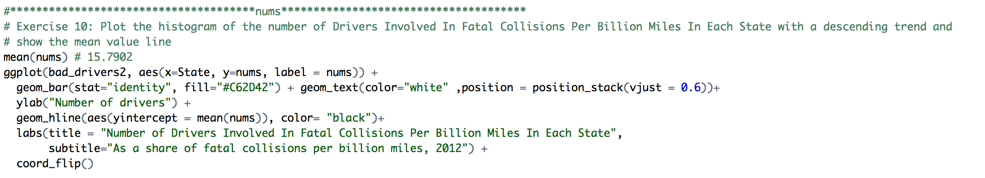



North Dakota and South Carolina have the highest number of such drivers for every billion miles traveled. Over the course of the 9.1 billi0n miles traveled in the state in 2011, 218 drivers were involved in 147 crashes. That produces a figure of 23.9 drivers involved in fatal collisions for every billion miles traveled — far higher than the national average of 15.7

# Exercise 11: Plot the histogram of the number of drivers Involved In Fatal Collisions Who Were Speeding In Each State, the total collisions and show the mean value line:

# 



Another way to put those fatal crashes in perspective is to determine whether the driver was speeding at the time. The data available for speeding-related fatalities is from 2009, when the NHTSA recorded 33,808 total traffic fatalities, 31 percent of which occurred while a driver was speeding. In Mississippi, just 15 percent of traffic fatalities (2.64 drivers) occurred while a driver was speeding, while in Pennsylvania, the share was 50 percent (9.1 drivers).

# Exercise.12: Plot the histogram of the number of Drivers Involved In Fatal Collisions While Alcohol Impaired In Each State, the total collisions and show the mean value line

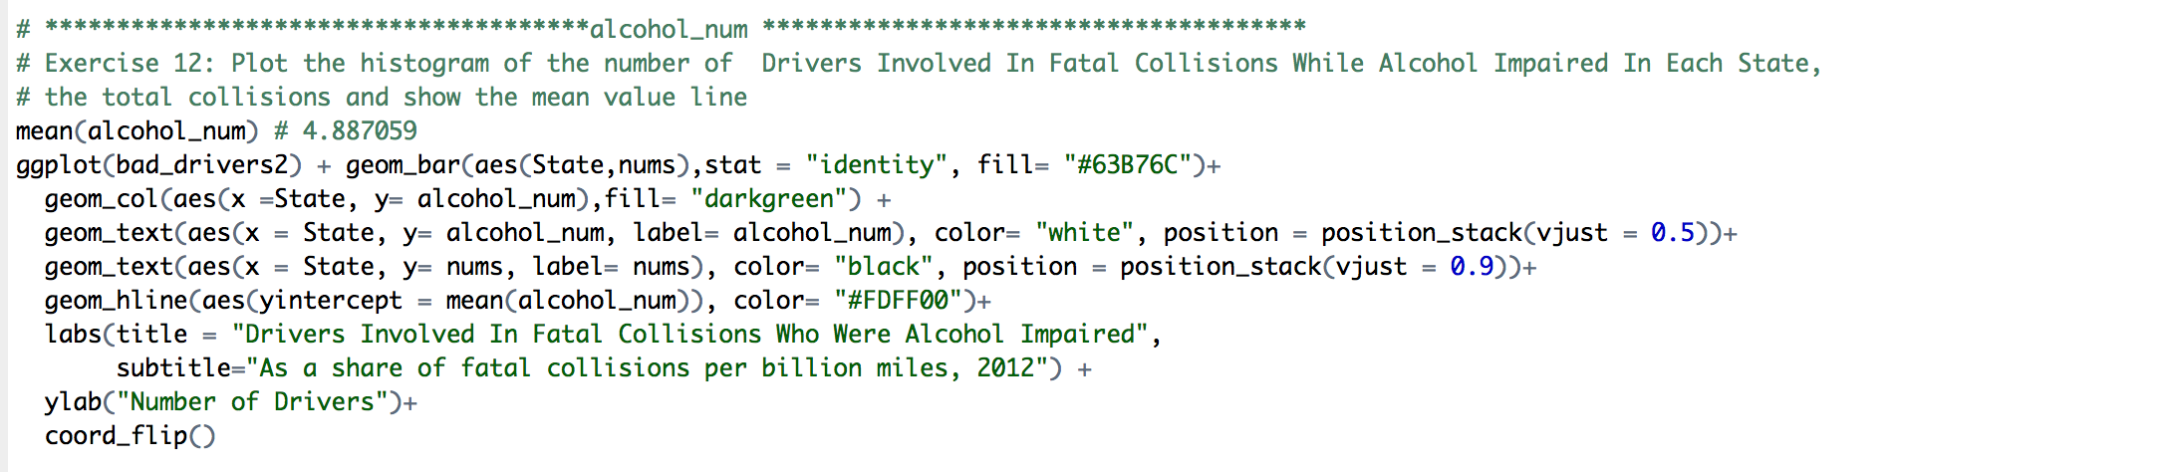

# 

Because it’s an irresponsible behavior, speeding is a good indicator of who’s a bad driver — so, too, is drunken driving. 31 percent of all traffic fatalities in 2012 occurred while a driver was alcohol-impaired. In North Dakota, 42 percent (10.04 drivers), In Montana, 44 percent (9.42 drivers) of traffic fatalities that year involved a driver who was alcohol-impaired, while in Utah, that figure was 16 percent (1.8 drivers).

# Exercise 13: Plot the histogram of the number of Drivers Involved In Fatal Collisions Who Were Not Distracted In Each State and the total collisions and show the mean value line:

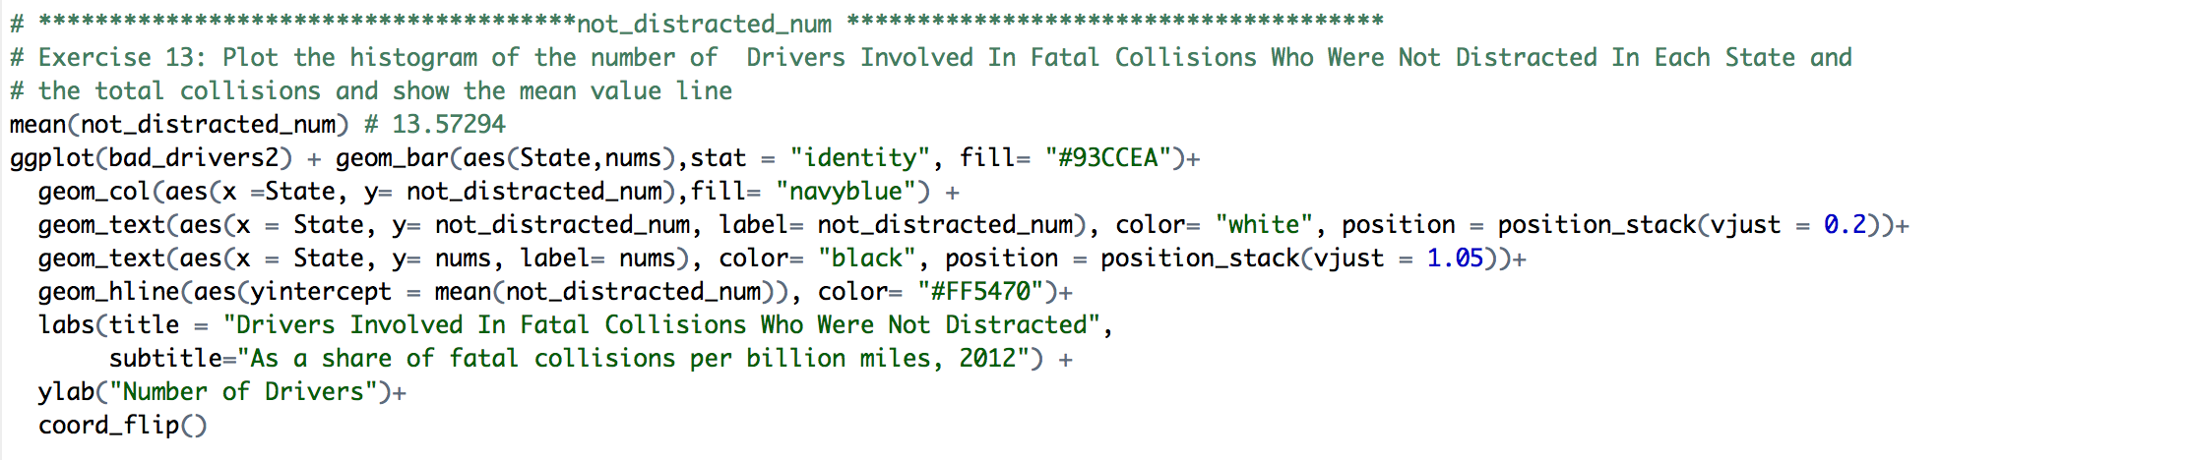



Whether a driver was distracted at the time of a fatal accident or not is also an important factor to look at. The background information: Of the 45,670 drivers involved in fatal road accidents nationwide in 2012, 3,758 were recorded as being distracted at the time (although it’s worth bearing in mind that in 8,991 cases, it was either not known or not recorded whether the driver was distracted). There’s detail on what those distractions were: 397 of those drivers were distracted by their cellphones, 39 were eating or drinking, and 17 drivers were simply “lost in thought/day dreaming.”

In both Ohio (13.96 drivers) and North Dakota (23.66 drivers), just 1 percent of drivers involved in fatal accidents were recorded as distracted, compared to 10 percent (13.58) nationally. But those percentages need to be treated with plenty of caution — it might sound pretty impressive that none of the drivers involved in fatal accidents in D.C. were recorded as being distracted at the time, but that’s based on only 10 drivers for which we have information.

# Exercise 14: Plot the histogram of the number of Drivers Involved In Fatal Collisions Who Had Not Been Involved In Any Previous Collision In each State and the total collisions, show the mean value line too

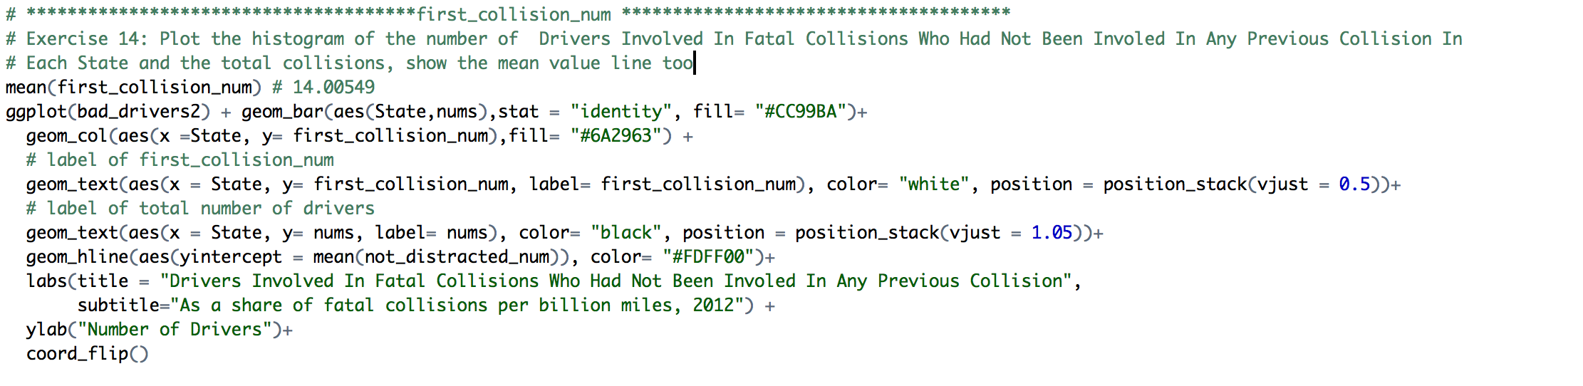



The database also shows whether drivers were involved in previous crashes. For 88 percent (14 drivers) of drivers nationally, it was their first crash. That figure varies by state, though. At the high end, in Idaho, 98 percent (14.99 drivers) of drivers hadn’t been involved in any previous collisions, while in New Jersey, at the low end, that figure was 78 percent (8.74 drivers).

**Exercise 15: Plot the histogram of the number of Car Insurance Premiums ($) In Each State with a descending trend and show the mean value line**

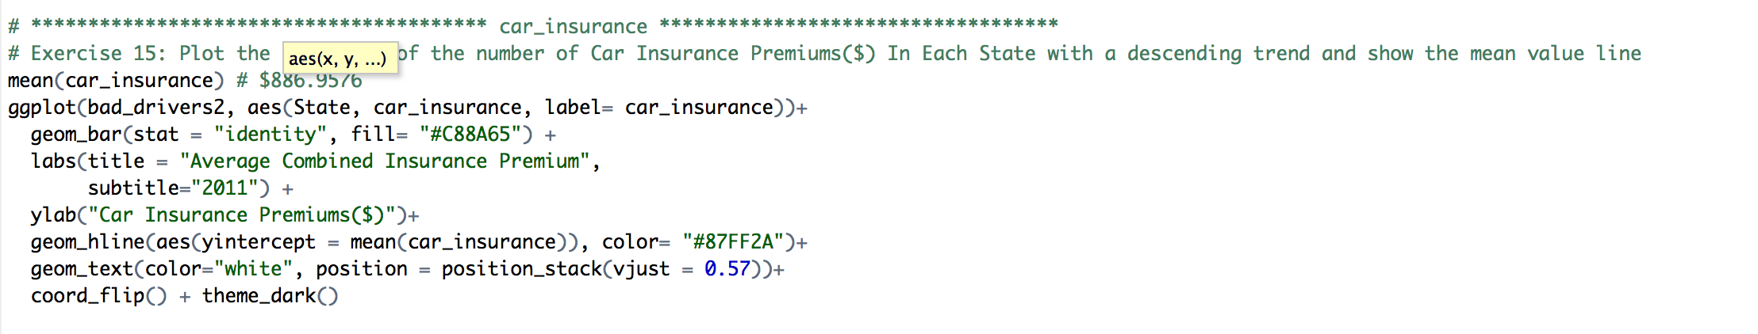



Those numbers probably aren’t news to insurance providers, who base their prices on a multitude of indicators, including driver behavior in accidents that weren’t fatal. So, average premiums in each state could reflect insurance companies’ overall assessment of who is likely to cost them in the future.

According to the figures from the National Association of Insurance Commissioners (NAIC), high-risk drivers are to be found in New Jersey, where at $1,302, car insurance is the most expensive in the country. Nationally, the average combined premium (collision, comprehensive, etc.) was $886 in 2011. On that same logic, Idahoans ($642), whose car insurance is on average less than half that, are the best drivers in the country.

**Exercise 16: Plot the histogram of the Loses Incurred By Insurance Companies ($) In Each State with a descending trend and show the mean value line:**

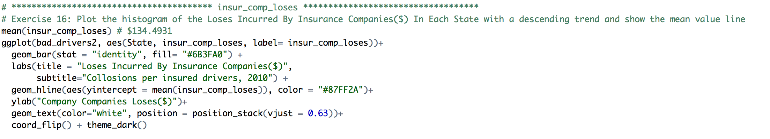



Yet again, Idahoans come out as America’s best drivers, costing insurers on average $83 each for collisions in 2010. New Jersey still don’t come off so good, costing insurers $160 apiece for collisions, but they’re still far behind the most expensive state, Louisiana, where it was $195.

**Exercise 17: Reshape the data-frame by using reshape function**

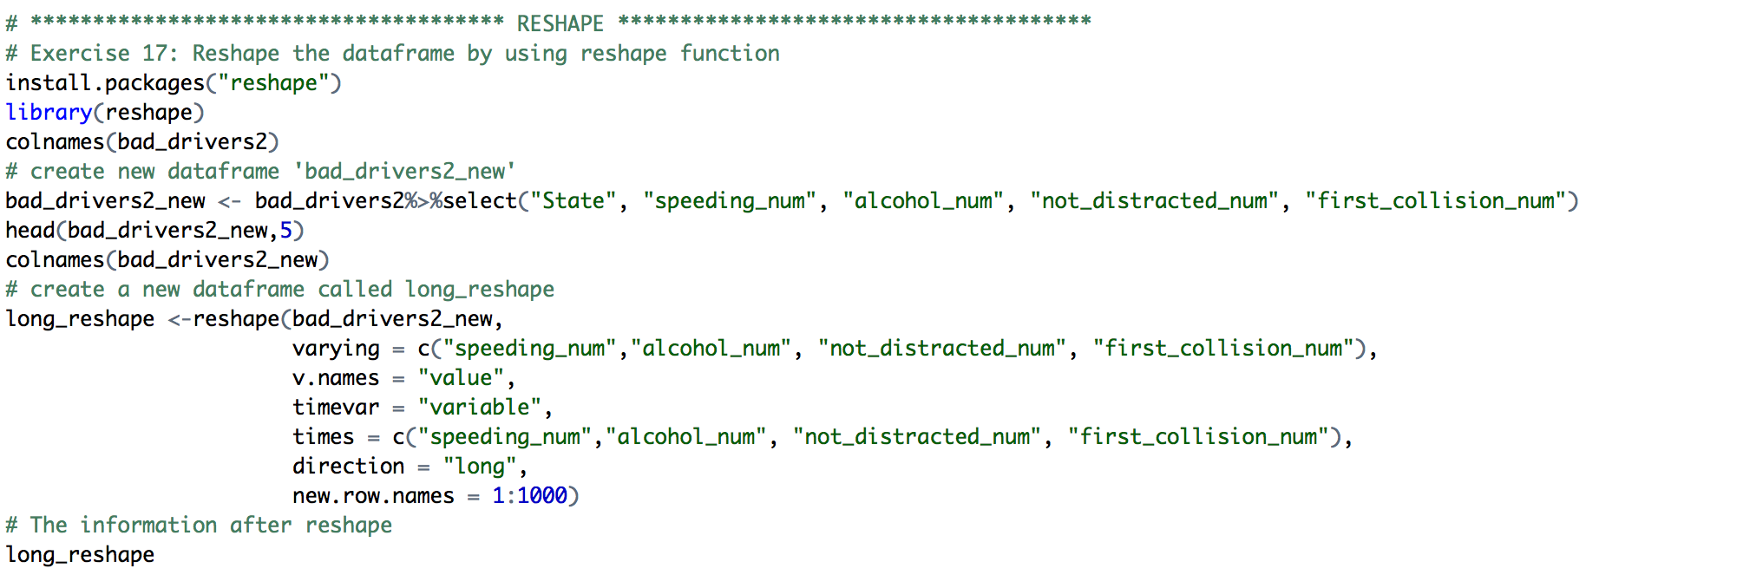

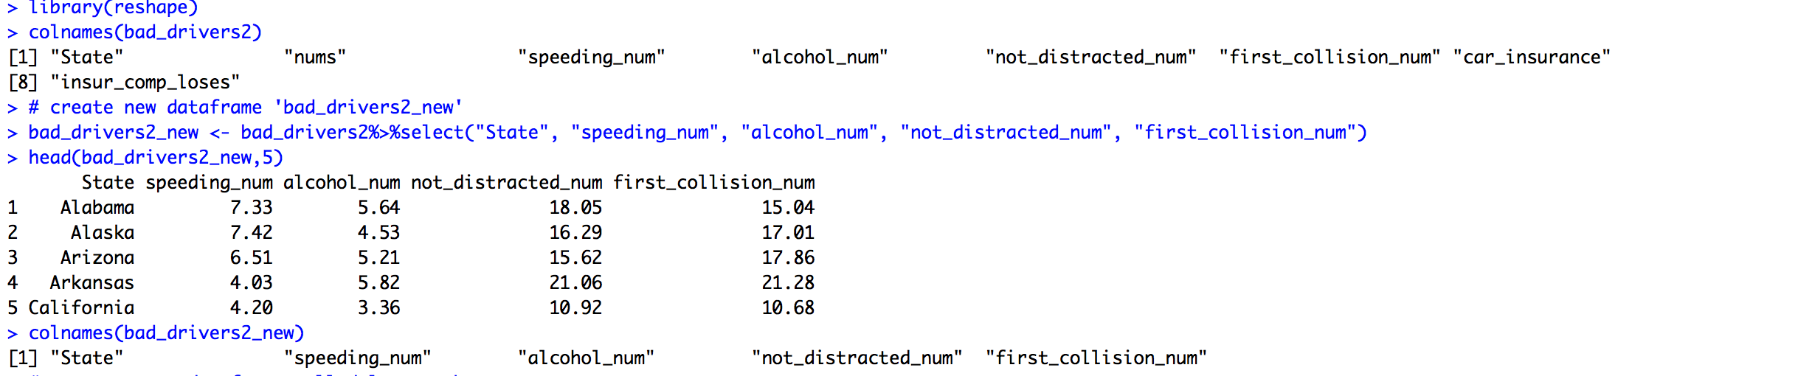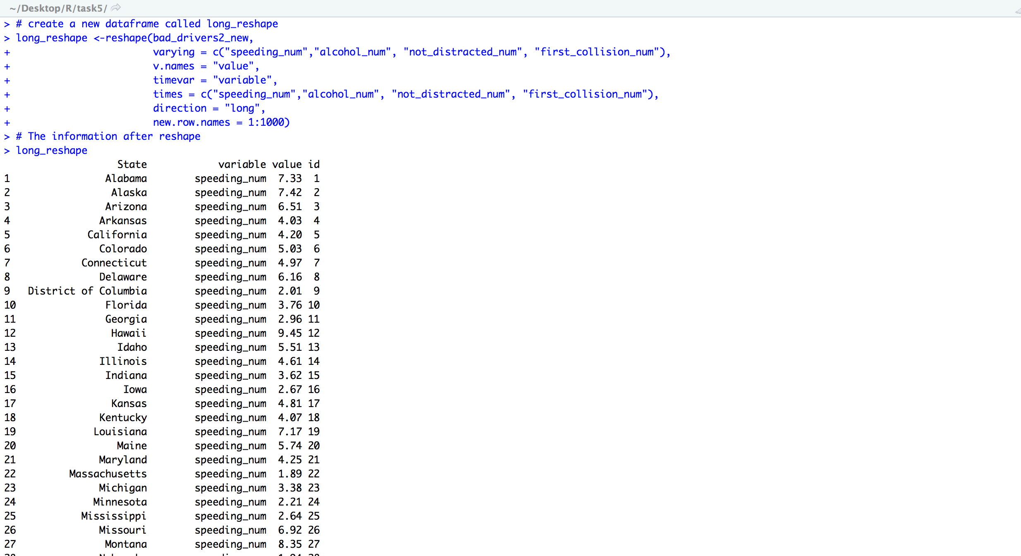

**Exercise 18: Plot the histogram based on the variables**





As we can see from this plot, North Dakota, South Carolina, West Virginia are the top three States have the worst drivers. Those who **had not been involved in any previous accidents** and those **who were not distracted** are the two main reasons that caused the collisions. It is very obvious to tell from this stacked graph. Collisions caused by **speeding** seems like the smallest reason among the four factors, the **alcohol driving** is second smallest reason triggered the collision in USA.

**Exercise 19: List the max value of each factor by reshaping the data-frame and show it out.**

